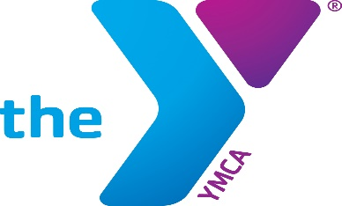Downtown Group Exercise Classes
Monday
9:30 AM Grey Panthers | Bob | Training Room
12:00 PM CrossTrain | Nora | Training Room
12:00 PM Spin | Luke | Spin Room
12:00 PM Sculpt | Melissa | Gym

Tuesday
12:00 Pilates | Sheri | Yoga Room
12:00 Boot Camp | Nora | Training Room
5:45 PM TBF | Sharon | Training Room

Wednesday
9:30 AM Grey Panthers | Sharon | Training Room
12:00 PM CrossTrain | Nora | Training Room
12:00 PM Spin | Melissa | Spin Room
12:00 PM Sculpt | Mary | Gym

Thursday
12:00 Pilates | Sheri | Yoga Room
12:00 Boot Camp | Nora | Training Room

Friday
9:30 AM Grey Panthers | Bob | Training Room
12:00 PM CrossTrain | Nora | Training Room
12:00 PM Spin | Misty | Spin Room
12:00 PM Sculpt | Melissa | Gym

